

REPORT ON DESIGN WORKSHOP



Members: Andrei Agape, Cristian – Dan Cojocaru, Cristina – Ioana Simionescu, David Green, Yoana Zaharieva
Class: DM83
University: UCN Technology & Business, Sofiendalsvej 60, Aalborg 9100
Date: November 9, 2012

CONTENTS

Contents

Summary 3
Main application functionalities 3
Use cases 3
Use case: Handling of Address Book 4
Use case: Handling of DVD 5
Brief use cases: Handling copies 6
Brief use cases: DVD is lent out 6
Brief use case: DVD is returned 7
Operation contracts 7
Operation contracts: Handling of Address Book 7
Operation contracts: Handling of DVD 9
Operation contracts: DVD is lent out 10
Operation contracts: DVD is returned 11
Sequence diagrams 12
Address Book sequence diagrams 12
Handling of DVD sequence diagrams 14
DVD is lent out sequence diagrams 15
DVD is returned sequence diagram 16
System sequence diagrams 16
Handling of DVD system sequence diagrams 17
DVD is lent out system sequence diagrams 18
DVD is returned system sequence diagrams 19
Design class diagram 20
Considerations about the architecture 21
Code standards 21
Description of the tests made 21
Evaluation of the group work 22
Conclusion 23

Summary

This report covers The Designing, Programming and Testing of an Address Book Workshop made by Group 2. The goal was to design, implement and test an address book software by following the Address Book Handling System, the DVD Handling System, the Loan and the Return System. Using the information provided in the handouts and the documentation requirements, the group designed use cases, operation contracts, sequence diagrams, system sequence diagrams, the design class diagram and the code. The following pages describe the progress of the group work in completing the assigned tasks, as well as some considerations on how the group collaborated to achieve the goals.

Main application functionalities

The application has to be able to:

- Handle the Address Book, which contains information about different people
- Handle DVDs, meaning storing a list of DVDs that can be rented
- Loan DVDs, which means a person can rent a copy of a DVD from the given list
- Return DVDs, which allows a person to end his loan

Use cases

Having identified the 4 use cases (Handling of Address Book – given in the handouts, Handling of DVD, DVD is lent out and DVD is returned), the group as a whole managed to prioritize them. Consequently, Handling of Address Book and Handling of DVD were described (by the members concerned with the design) fully-dressed, while Handling copies, DVD is lent out and DVD is returned were divided into brief use cases.

Use case: Handling of Address Book

Level:
User-Goal

Primary actors:
Private Person

Stakeholders and Interests:
Person wants to be able to register personal information, to change it, to get it and to delete it.

Preconditions:
User has program opened.
User wants to register in the address book.

Success guarantee (post conditions):
Personal information is registered in the address book.
Personal information can be accessed.
Personal information is modified.
Personal information is deleted.

Main success scenario:
- User opens the program.
- System asks for personal information.
- User inputs personal ID, name, address, postal code, and city and phone number.
- System saves the information to database.
- User accesses his information by inserting his ID.
- System displays the information.
- User wants to modify his personal information.
- System acknowledges the modification.
- User deletes the entry by inserting ID
- System deletes the entry.

Extensions:

2a: Same id entered
    - System asks for valid ID, ID already exists.
    - User types another ID.
2b: Same phone number entered.
      - System asks for valid phone number.
      - User types a valid phone number.
4a, 6a, 8a: ID not found.
    - System asks for valid ID.
    - User inserts a valid ID.

Frequency of occurrence: regularly

Use case: Handling of DVD
Level:
User-Goal

Primary actors:
Private Person (User)

Stakeholders and Interests:
User wants to be able to register a DVD in the system update and delete it.

Preconditions:
User has chosen to register DVD.

Postconditions:
DVD is registered in system.
DVD information can be accessed in the system.
DVD information can be modified.
DVD information can be deleted.

Main success scenario:
- User wants to create a DVD.
- User inputs DVD information id, title, artist, and publication date.
- System saves the information to database.
- User accesses the DVD by title.
- System displays the information wanted.
- User wants to modify the DVD information.
- System acknowledges the modification.
- User wants to delete DVD from system.
- System deletes the entry.

Extensions:

2a: DVD has already been registered in the system.
    - System prints that the DVD has already been registered.
    - User inserts new attributes.
4a, 6a, 8a: DVD is not found in the system.
    - System prints that DVD is not found in the system.
    - User inserts another title.

Frequency of occurrence: regularly

Brief use cases: Handling copies

Use Case (brief): Create a copy
A user wants to insert information for a copy of a DVD. He inputs serial number, purchase date and purchase price. The system saves the entry and adds the copy to the DVD class.

Use case (brief): Modify a copy
User makes changes in the information about the copy. The system saves the new information and implements the changes in the DVD class.

Use case (brief): Remove a copy
User wants to delete a copy. He enters the serial number. The system removes the chosen copy.

Use case (brief): Get copy information
User wants to receive information about the copy by inserting the serial number. The system prints out the details for the copy.

Brief use cases: DVD is lent out

Use Case (brief): Create a copy
A user wants to insert information for a copy of a DVD. He inputs serial number, purchase date and purchase price. The system saves the entry and adds the copy to the DVD class.

Use case (brief): Modify a copy
User makes changes in the information about the copy. The system saves the new information and implements the changes in the DVD class.

Use case (brief): Remove a copy
User wants to delete a copy. He enters the serial number. The system removes the chosen copy.

Use case (brief): Get copy information
User wants to receive information about the copy by inserting the serial number. The system prints out the details for the copy.

Brief use case: DVD is returned

User wants to return a copy of a DVD. System asks for id of the DVD, the serial number of the copy and the purchase date. User inserts the information. System saves the changes.

Operation contracts

The part of the group in charge with the design then started creating the operation contracts that were identified depending on the needs of the application. For every scenario, we found numerous operation contracts.

Operation contracts: Handling of Address Book

Operation Contract: createPerson
Operation: createPerson(id: int, name: String, address: String, postalCode: int, city: String, phone: String)
Cross reference: Use Case: Handling of Address Book
Preconditions: None
Post conditions:
-An instance of Person is crated (instance creation)
-A Person is stored in the ArrayList<Person> in the Address book (association formed)

Operation Contract: getPerson

Operation: getPerson(id)
Cross reference: Use Case: Handling of Address Book
Preconditions: Person exists in the ArrayList<Person>
Postconditions:
- person.getPerson(id) – information about the person chosen is given

Operation Contract: updatePerson

Operation: updatePersonAddress(searched: int, address: String)
updatePersonCity(searched: int, city: String)
updatePersonName(searchId: int, name: String)
updatePersonPhone(searched: int, phone: String)
updatePostalCode(searched: int, postalCode: int)
Cross reference: Use Case: Handling of Address Book
Preconditions: The Person object has been found in AddressBook
Postconditions:
-person1.updatePersonAddress(searched: int, address: String) – address modified (attribute modification)
-person1.updatePersonCity(searched: int, city: String) – city modified (attribute modification)
-person1.updatePersonName(searchId: int, name: String) – name modified (attribute modification)
-person1.updatePersonPhone(searched: int, phone: String) – person modified (attribute modification)
-person1.updatePostalCode(searched: int, postalCode: int) – postal code modified (attribute modification)

Operation Contract: removePerson

Operation: removePerson(id: int)
Cross reference: Use Case: Handling of Address Book
Preconditions: The Person object has been found in the AddressBook
Postconditions:
- person1.removePerson(id) – person is removed from the AirrayList<Person> (association formed)

Operation contracts: Handling of DVD

Operation Contract: addDVD
Operation: addDVD (id: int, title: String, artist: String, publicationDate: String)
Cross reference: Use Case: Handling of DVD
Preconditions: none
Postconditions:
- A new instance of DVD is created. (instance creation)
- The instance is stored in ArrayList<DVD> in DVDcontainer class (association formed)
- Attributes of the object are initialized.

Operation Contract: modifyDVD
Operation: modifyDVD(id: int, title:String, artist:String, publicationDate:String)
Cross reference: Use Case: Handling of DVD
Preconditions: The DVD has been found in ArrayList<DVD>
Postconditions:
- DVD.changeArtist(id) – artist is modified
- DVD.changeId(id) – id modified
- DVD.changePublicationDate(id) – publication date modified
- DVD.changeTitile(id) – title modified
- Attributes are modified.
Operation Contract: removeDVD
Operation: deleteDVD(id: int)
Cross reference: Use Case: Handling of DVD
Preconditions: A DVD has been found in ArrayList<DVD> in DVDcontainer class.
Postconditions:
- DVD.removeDVD(id) – the DVD chosen is removed from the Array List of DVDs.

Operation contracts: DVD is lent out

Operation contract: createLoan

Operation: createLoan()
Cross reference: Use Case (brief): Creating a loan
Precondition: None
Postcondition: - An instance of Loan is created
- The instance is stored in ArrayList<Loan> in the LoanContainer class
- Attributes of object are initialized

Operation contract: getLoan

Operation: getLoan()
Cross reference: Use Case (brief): Viewing details about a loan
Precondition: A loan has been found in ArrayList<Loan> in Loancontainer class.
Postcondition: Attributes of Loan object are returned

Operation contract: modifyLoan

Operation: modifyLoan()
Cross reference: Use Case (brief): Changing loan details
Precondition: A loan has been found in ArrayList<Loan> in Loancontainer class
Postcondition: Attributes of Loan object are modified

Operation contract: deleteLoan

Operation: deleteLoan()
Cross reference: Use Case (brief): Canceling a loan
Precondition: A loan has been found in ArrayList<Loan> in Loancontainer class.
Postcondition: Loan object is deleted from the ArrayList<Loan> in Loancontainer class

Operation contracts: DVD is returned

Operation: returnCopy(personId: int, dvdId: int, serialNumber: int, purchaseDate: int)
Cross reference: Brief use case: DVD is returned
Preconditions: The copy has been lent out.
Post conditions:
- Attributes of the copy are inserted.
- changeCopyAvailability () -the availability of the copy is changed.
- removeCopy(personalId, serialNumber, purchaseDate) – the copy is removed.

Sequence diagrams

Based on the source code written by 2 members of the group, the other 3 members designed the sequence diagrams in Microsoft Visio using standard UML notation, to show the sequential and parallel activities in the identified processes.

Address Book sequence diagrams

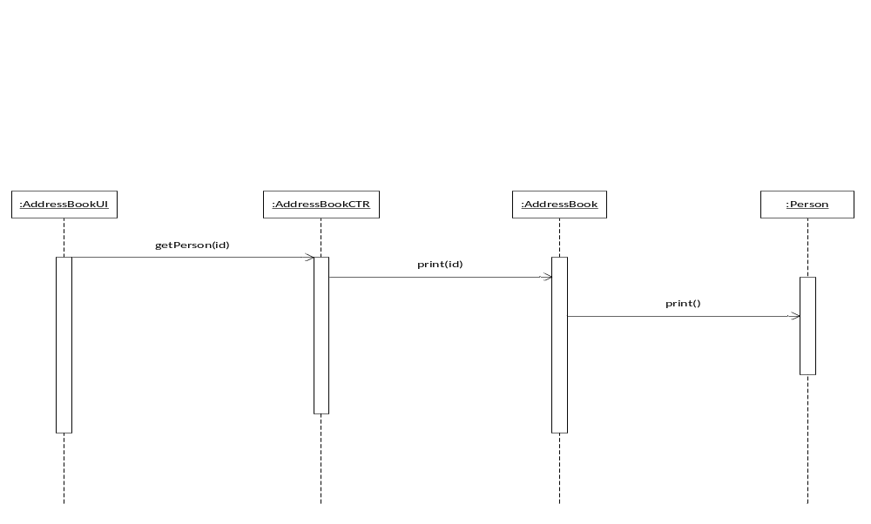
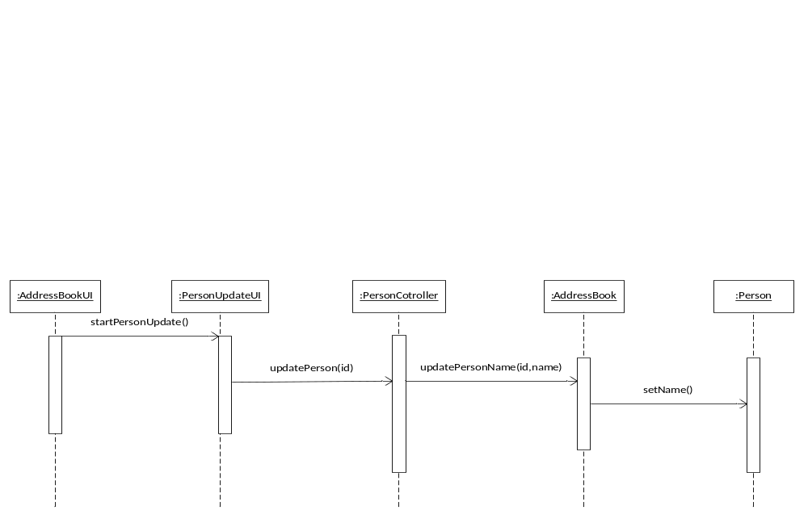
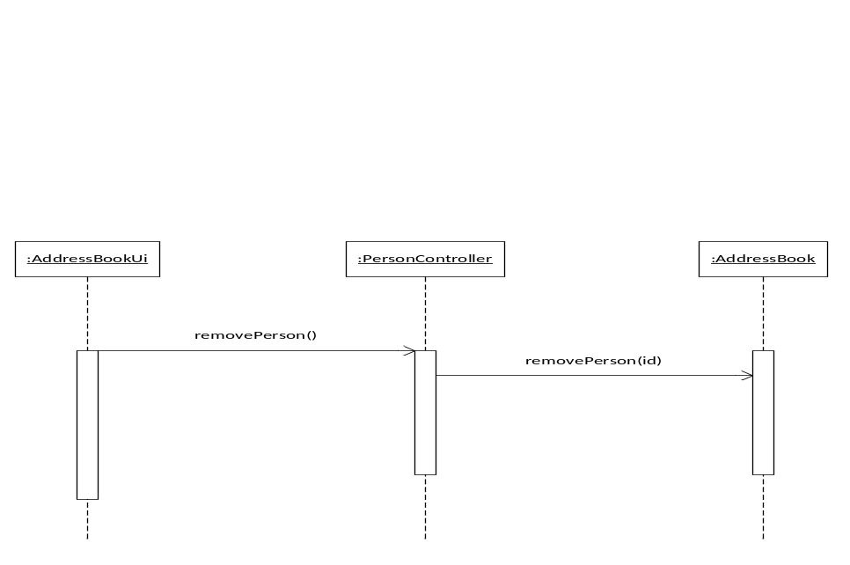

Handling of DVD sequence diagrams
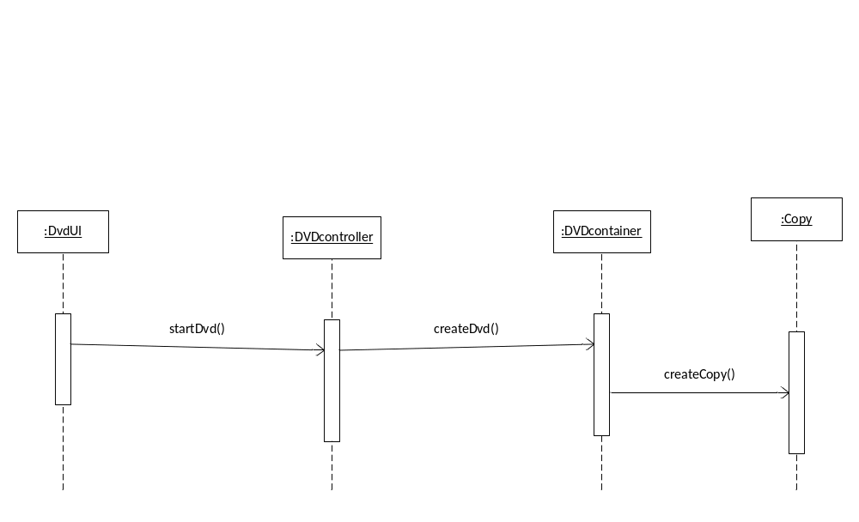
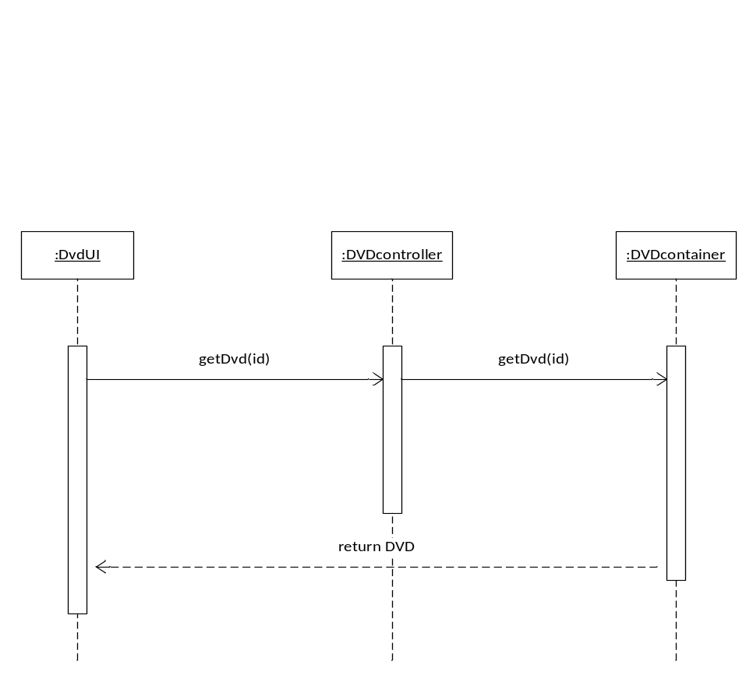
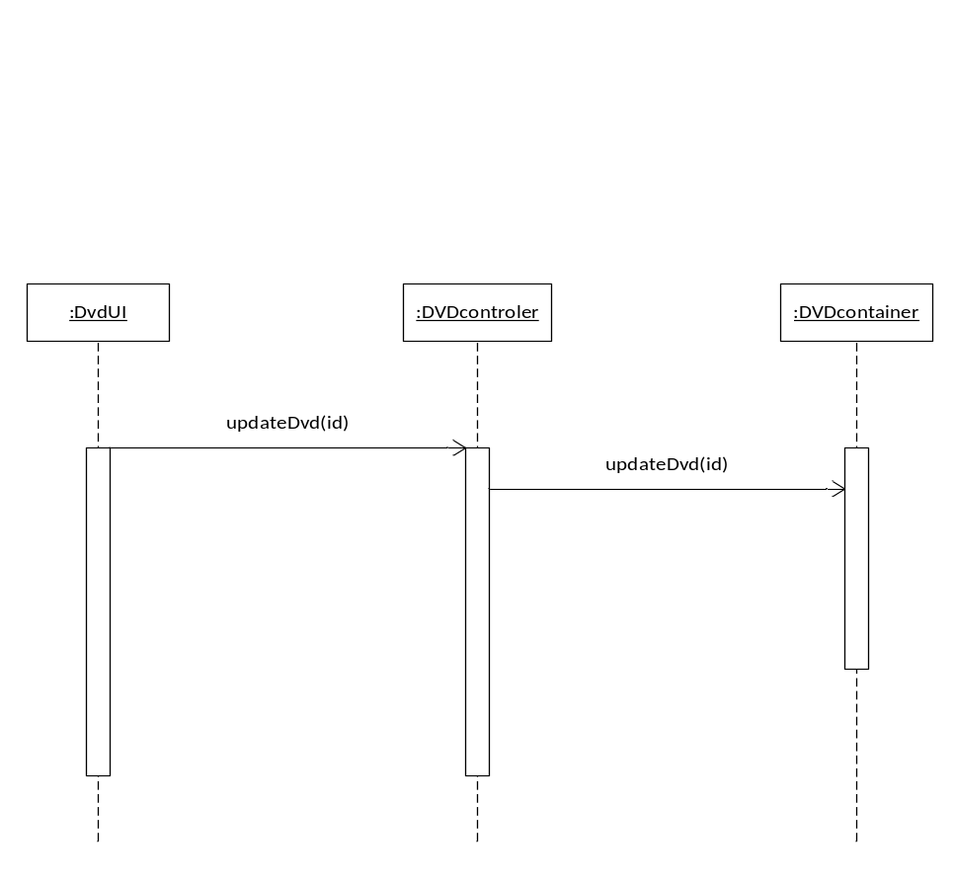

DVD is lent out sequence diagrams
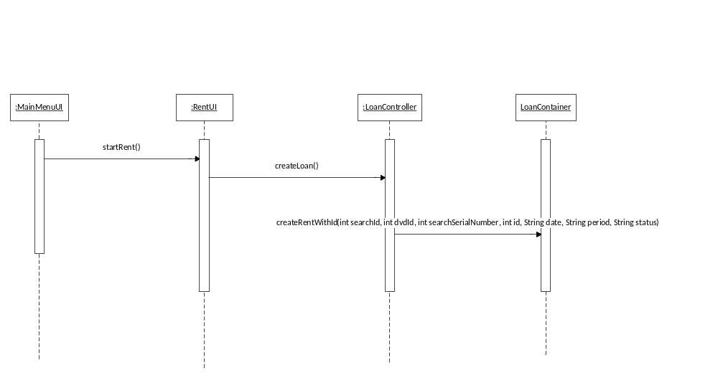

DVD is returned sequence diagram

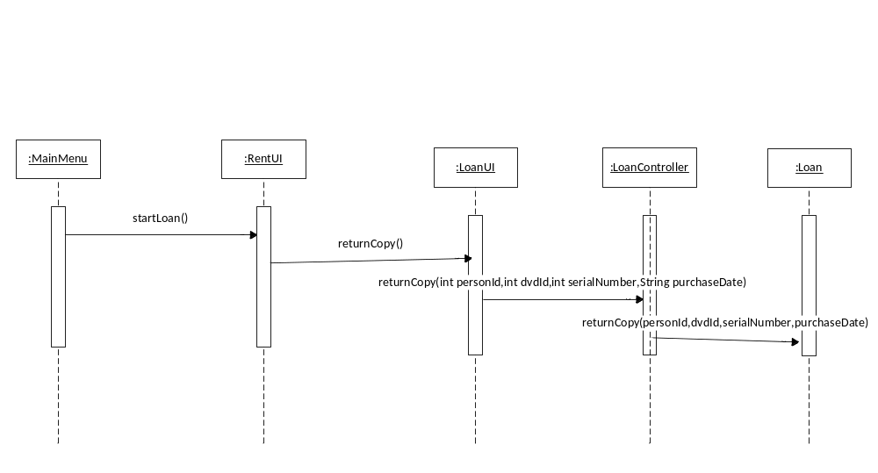

System sequence diagrams

By following the sequence diagrams designed previously, the group members who were assigned the design part started putting together the sequence diagrams for every process, again by using standard UML notation in Microsoft Visio.

Handling of DVD system sequence diagrams
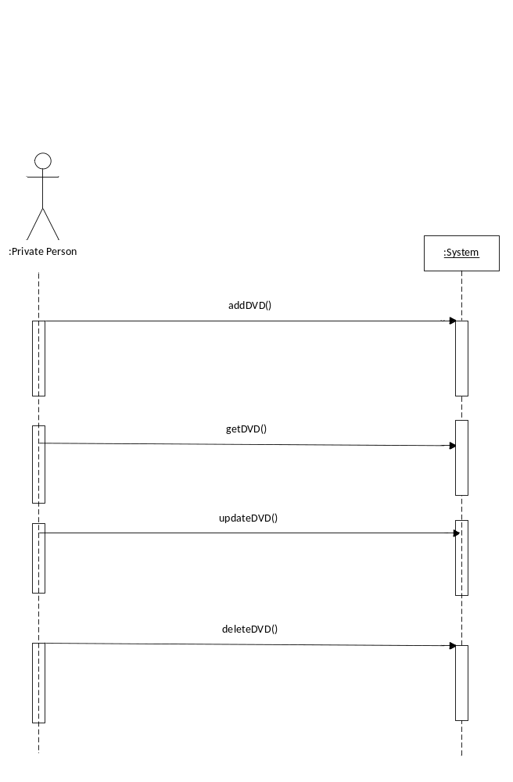
DVD is lent out system sequence diagrams 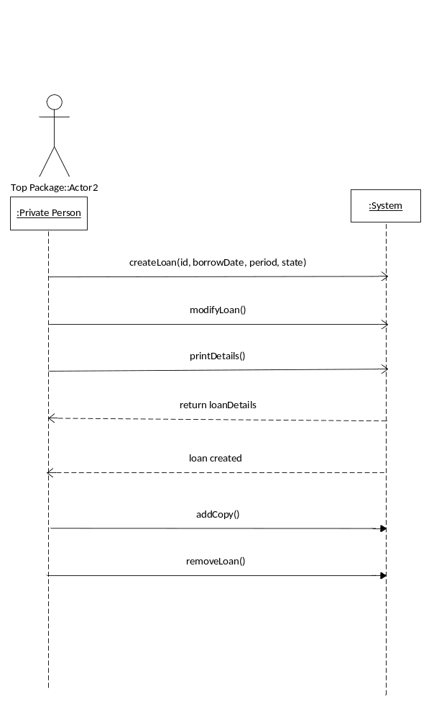

DVD is returned system sequence diagrams
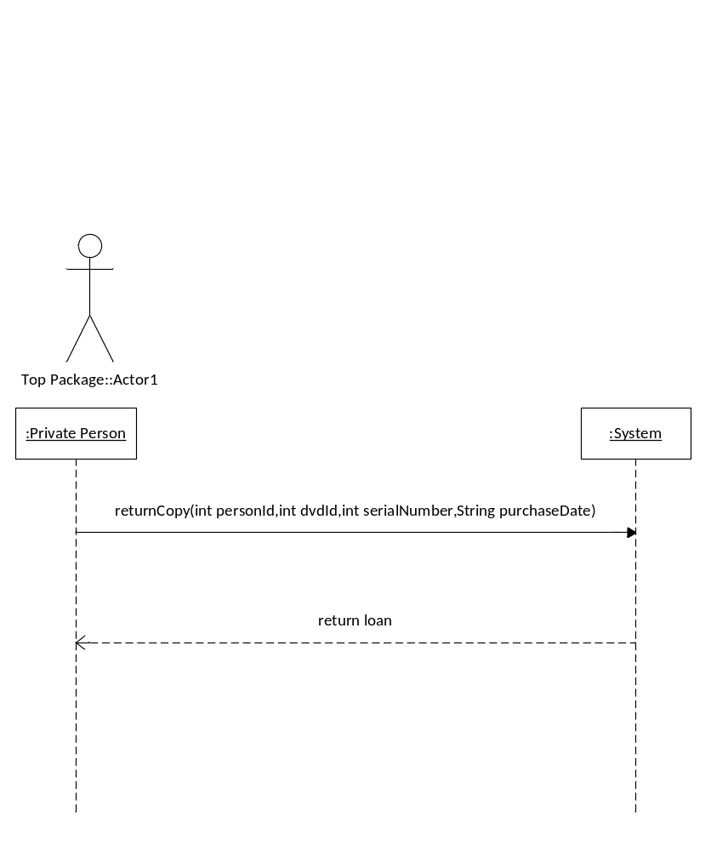

Design class diagram

Making constant changes to the design class diagram was a challenge the group faced during the working process. Updates had to be performed after every iteration due to the addition of new classes. The sequence diagrams played an important role in this stage, as they outlined the classes and methods that needed to be added to the diagram.

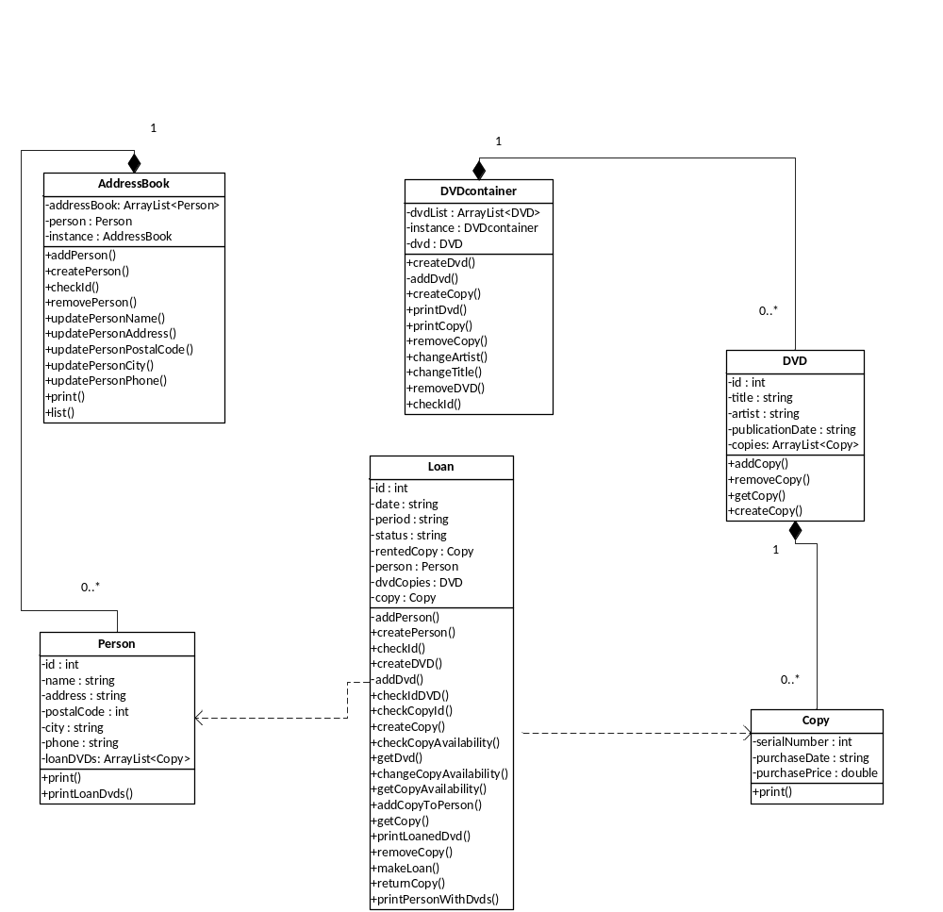

Considerations about the architecture

For this project, Andrei and Cristian used a three-layered architecture(Model – View – Controller) and the Singleton pattern, taking into consideration the advice given during the lectures. During the first day of the workshop, they created the Model package, leaving the Controller and the User Interface Packages for the second day. In spite of this, they faced several obstacles during the process, meaning that they also had to make changes in the following days. Due to these decisions, as well as constant testing with the aim of finding bugs and what parts need alterations, the coding process came out as a success.

Code standards

When writing the code, the part of the group in charge took into account several rules about naming, layout, documentation and language use.
As for what naming is concerned, they used meaningful names, they used singular nouns class names (which they started with capital letters) and they made sure that the method and variable names started with low-case letters.
For the layout part, they made sure that braces were used in a correct way, blank lines were added between methods and constructors and spaces were placed around operators and before the opening brace of a control structure’s block.
Since documentation is also an important part, the members decided to add comments only when necessary, such as at the top of every class and for every method, while at the same time making them Javadoc-readable.
Last, but not least, they tried to use proper language: the order of declarations was followed, both private and public fields were created, the classes were imported separately and a constructor that initialized all the fields was always added, regardless of the content of the body.

Description of the tests made

In order to check whether the source code was running properly and to correct the possible mistakes, the group as a whole ran a few tests that proved to be essential in the process.

- Test 1: One of the tests performed involved trying to add a person to the address book by inserting an ID that already existed, knowing that this should return an error (negative testing). As expected, the message ‘ID already exists.’ was printed.

- Test 2: Another test included adding DVDs to the DVDcontainer class and then printing a list of all DVDs to check if the correct information is printed (positive testing). Consequently, all DVDs that had been added were printed.

- Test 3: When making a new loan, we checked to see if the availability of the rented copy changes, which was again an example of positive testing. After running the test, our expectations were met.

Evaluation of the group work

Group 2 consists of five people, Andrei, Cristian, Cristina, David and Yoana, who managed to work together in a group and to improve interpersonal and communication skills. The project needed to be done in five days and it was useful for everyone to test their abilities in a dynamic working environment. There was not a formal leader, all of the members worked together for the specific goal.

Satisfaction of the group process
Generally the group is satisfied with the process. Members managed to cooperate easily and to communicate freely. Everyone was calm and managed to cope with every problem that occurred.

Self evaluation
Members are satisfied with their performance. However, if more time was available, a lot more positive changes to the system could have been made. It is generally accepted that most members gave a lot of themselves to finish the workshop on time.

Communication
Generally the group discussed every step together. Cooperation and communication between the members were good. Everyone managed to fit in a group and to reach their aim at the parts of the project they were supposed to do.

Leaders
It was decided that that the group is not supposed to have a leader. Members worked as a team without formal or informal leader.

Supervision
There was not a project manager of the group. All members took different initiatives in order to contribute to the finishing of the workshop.

Vision of the project
Members believe that if more time was available more changes could have been done. However, the general attitude is positive and team workers are satisfied.

Testing the system
All of the members at some time or another tested the system. If a bug was found, the members that did the programming tried to fix it as soon as possible.

Rules and regulations
All rules and regulations were informal. Members were present and ready for work.

Respect
The atmosphere in the group was good. Members managed to find a good way of cooperation and working as a team.

Conclusion

In conclusion, the workshop task outlined the functionality and gave the group a broader understanding of the means of developing, implementing and testing a simple but useful application. On top of this, the group work improved the members’ abilities to cooperate and communicate with each other, share ideas, interact, make suggestions, connect, provide help when needed and show respect, which resulted in a productive environment for the desired outcome.

